**Review Sheet #2**

MTH 125

Fall 2018

1. Write C++ statements to carry out the following flow chart.

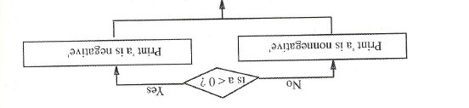

1. If and . what are the values of and after the following statements are executed?

1. Add to the area of a circle program (#4 on Review Sheet 1) the necessary statements to test if the radius is negative. If so, print a suitable message and bypass the computation of the area.
2. Are the following logical expressions true or false when and ?
3. Give the result of the following nested if statement for the cases

